|  |  |
| --- | --- |
| Restaurant Billing System | 2 |

**ABSTRACT**

This project is aimed at developing a Restaurant Billing System. The purpose of the project is to develop a user-friendly GUI based billing system. The application can be accessed and effectively used by the user.

A simple GUI is provided for the easy access. The system’s design is so simple that users won’t find it difficult to use and understand.

A billing system can be very useful within a business environment. Instead of making bills manually or to sum up the total manually, it is very much time consuming and also may have some human errors like adding up the wrong total or adding wrong items into the bill. When making a hand written bill the owner and customer both have to repeatedly check the total, items added, etc. It also sometimes results into a Bad Impression towards the Restaurant from a Customer. Ideally, user should be able to generate bill without any mistakes and quickly, enabling them to fasten or improve their process. To overcome this problem, we have come up with this project, that is, Restaurant Billing System Using Python

|  |  |
| --- | --- |
| Restaurant Billing System | 5 |

**INTRODUCTION**

Python is known for its general-purpose nature that makes it applicable in almost each domain of the software development. Python as a whole can be used in any sphere of development.

The project has been implemented in python. The system contains the menu which is available in the restaurant. The owner or the cashier has to check the item ordered by the customer and enter the number of orders given for a particular item in the menu. Once the items are selected, the cashier can click on total to obtain the total for drinks and the food separately. It displays the service charges and the tax also. When the cashier clicks on the receipt button, the receipt is generated.

**Limitations of the Existing System:**

There are many problems which are faced in current billing systems.

* Proper charges on each item will not be given.
* No details on taxes or service charges will be mentioned.
* Some restaurants issue the hand written bills with no detail of the charges mentioned.

|  |  |
| --- | --- |
| Restaurant Billing System | 6 |

**PROBLEM IDENTIFICATION**

Since many restaurant or café owners make bills for their customers manually with a pen paper. This sometimes results into an error of total or wrong items added or some items missing in bill or extra items added. This may end up by building up a bad impression of customer towards the Café or restaurant. So, to overcome this problem we’ve come up with this helpful project named Restaurant Billing System Using Python.

We all love going to cafes or restaurants but when it takes time for them to make a bill or if they Make wrong bill then it’s time consuming. So, to avoid all such chaos our project will help in All possible terms.

|  |  |
| --- | --- |
| Restaurant Billing System | 7 |

**SYSTEM REQUIREMENTS**

**Software Requirements**

Operating System: Windows 10

Tools : Python idle

**Hardware Requirements**

Processor

RAM

Hard Disk

Input device

Output device

: Any Processor above 500 MHz

: 4GB

: 1TB

: 104 Keys standard keyboard

: Laptop Display Screen

|  |  |
| --- | --- |
| Restaurant Billing System | 8 |

**PROPOSED METHEDOLOGY**

The proposed system imports tkinter, random, time and datetime for the implementation of the system.

The frames are created for the title, menu (beverages & food) and the receipt. These frames have several suitable buttons and checkboxes. Title contains the title of the project. The menu contains the details of the items available in the restaurant. Receipt contains the bill which will be generated.

The manager, cashier or the owner will first check the box of the ordered items and mention the number of orders of each item in the menu. The manager then clicks on total button to get the total, subtotal, tax, service charges etc. Then will click on the receipt button to get the automatically generated bill. To place the next order, reset option can be clicked to clear the text fields.

|  |  |
| --- | --- |
| Restaurant Billing System | 9 |

**SYSTEM IMPLEMENTATION**

Restaurant Billing System is developed using Python. While using this billing management system, you can easily calculate total bill of the customer. Moreover, the total bill iS calculated including service charges and state tax. All you need to do is just fill up the blank boxes with item quantities and click on total button. The program will display your total bill. This system can be used in restaurants, cafe and food truck for calculating bills in a short period of time and it’s not time consuming. It’s easy to operate and understand by users. There is no any error and warning contents in the project. The design is so simple that user won’t find it difficult to use and navigate.

To ease the use of the user we even have a calculator added to our system which performs all basic operations like Addition, Subtraction, Division and Multiplication. We’ll display Menu, Order no., Total and Reset. We assure that the project is bug free and easy to use.

Since the program is for restaurant or providing services. It will add services charges and state taxes respectively.

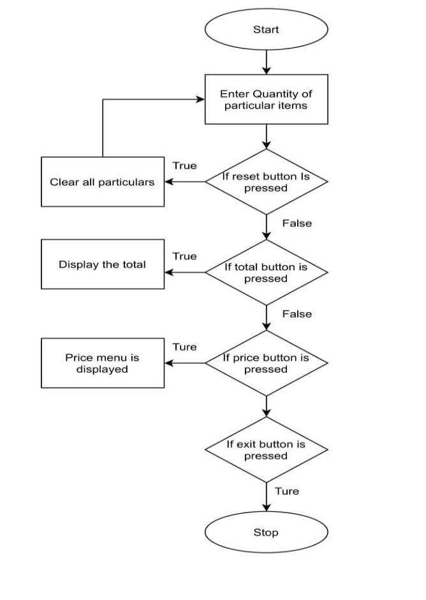

**Fig -3**: Restaurant Billing System Using Python Flowchart



|  |  |
| --- | --- |
| Restaurant Billing System | 10 |

**CONCLUSION**

The urge for the digital restaurant management systems is increasing day by date. Restaurant Billing System Using Python is a perfect solution for this. Through this the ease of access and flexibility of the day to day works in the restaurant is made simpler. The features such as bill number, CGST and SGST make this software user friendly. Both the management side and worker site can manage the data easily using such a system. It is very good and reliable system which can be in corporate to the chain of hotels so can easily maintained and addressed

|  |  |
| --- | --- |
| Restaurant Billing System | 11 |

**REFERENCES**

1. Python for Everybody, Charles R. Severance
2. www.python.org
3. www.geeksforgeeks.org
4. [www.w3schools.com](http://www.w3schools.com)

|  |  |
| --- | --- |
| Restaurant Billing System | 3 |
|  |  |

**ACKNOWLEDGEMENT**

We would like to express our sincere gratitude to our guide for her/his encouragement and constant guidance, without her/his continued support and insights throughout this work, this project could not have been completed.

We are thankful to **Dr Satish Soni**, HOD of Computer Science & Engineering for his encouragement.

We convey my sincere thanks to all teaching and non-teaching staff of computer science and engineering department for their kind cooperation.

We also extend thanks to my colleagues and friends who have been cooperative during the entire project work.

**Vikas Kumar Namdeo**

**0306CS191027**

**Gaurav Kushwaha**

**0306CS191010**

|  |  |
| --- | --- |
| Restaurant Billing System | 4 |

**OVERVIEW**

* Introduction
* Problem Identification
* System Requirement
* Proposed Methodology
* System Implementation
* Conclusion
* References

|  |  |
| --- | --- |
| Restaurant Billing System | 3 |

**ACKNOWLEDGEMENT**

We would like to express our sincere gratitude to our guide for her/his encouragement and constant guidance, without her/his continued support and insights throughout this work, this project could not have been completed.

We are thankful to **Dr Satish Soni**, HOD of Computer Science & Engineering for his encouragement.

We convey my sincere thanks to all teaching and non-teaching staff of computer science and engineering department for their kind cooperation.

We also extend thanks to my colleagues and friends who have been cooperative during the entire project work.

**Vikas Kumar Namdeo**

**0306CS191027**

|  |  |
| --- | --- |
| Restaurant Billing System | 3 |

**ACKNOWLEDGEMENT**

We would like to express our sincere gratitude to our guide for her/his encouragement and constant guidance, without her/his continued support and insights throughout this work, this project could not have been completed.

We are thankful to **Dr Satish Soni**, HOD of Computer Science & Engineering for his encouragement.

We convey my sincere thanks to all teaching and non-teaching staff of computer science and engineering department for their kind cooperation.

We also extend thanks to my colleagues and friends who have been cooperative during the entire project work.

**Gaurav Kushwaha**

**0306CS191010**